This is a three part series on Cognitive science’s impact on teaching. The first part below provides context and evidence for the claims of educational CogSci and the subsequent parts will cover examples of teaching and assessing knowledge (skills are a subcomponent) and in planning a scheme of work using CogSci principles.
The sources of the claims can be examined by clicking on the number in the brackets
Cognitive science (1) has developed sufficient scientific evidence to “assert that more than enough is known to sustain a "scientific" model of learning” and that this model sufficiently covers “all learning described by the word "thought", as well as anything we might try to teach, or instruct in formal educational settings” (2)
The failure of learning theories (3) (eg VAK, Multiple intelligences, Constructivism) and taxonomies (eg Bloom’s, SOLO, De Bono, transferable generic and higher order thinking skills) when tested experimentally explain “Why Minimal Guidance During Instruction Does Not Work” “(An Analysis of the Failure of Constructivist, Discovery, Problem-Based, Experiential, and Inquiry-Based Teaching)” (4)
In educational research the lack of control groups for comparison, inability of replication of the results and small sample sizes led “many educators [to] confuse constructivism which is a theory of how one learns and sees the world, with a prescription of how to teach” Constructivism itself remains an unverified theory due to the untestable (tautological) nature of its claims (5) and part of a wider replication crisis in psychology (6)
This has led to a “case for fully guided instruction” as the “research has provided overwhelming evidence that, for everyone but experts, partial guidance during instruction is selectively less effective than full guidance” (7) and therefore the need for “a scientific mental model of the learner” (8)
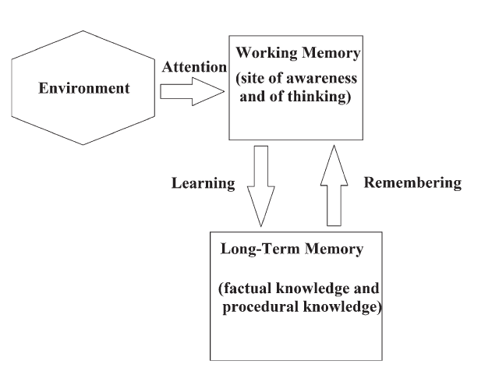
In summary it requires a different paradigm than the conventional.
- “Indeed, many randomised, controlled trials that now have been run indicate that too many recommended instructional procedures are useless.” “if nothing has been retained in long-term memory, nothing has been learned.”
- “There is little more useless than attempting to teach generic thinking skills and expecting students to be better thinkers or problem solvers as a result.
- Despite decades of work, there is no body of evidence supporting the teaching of thinking or other generic skills…
- It is a waste of students’ time placing these skills in a curriculum because we have evolved to acquire them without tuition.
- While they are too important for us not have evolved to acquire them, insufficient domain [subject]-specific knowledge will prevent us from using them. Prof John Sweller (9)
- “Much of what is commonly taken to be rote knowledge is in fact not rote knowledge.
Rather, what we often think of as rote is, instead, inflexible knowledge, which is a normal product of learning and a common part of the journey toward expertise.” Prof Daniel Willingham (10)
- A list of 10 (CogSci) principles for learning and an example of its application can be found here
Based on CogSci research if a student has not memorised ‘it’ they can’t think about ‘it’ and our SOW’s should be designed to maximise retention and assessment of what is in long term memory.

