Cognitive Science and its impact on teaching Part 2 of 3 (Sri Pavar)
Page 1 continues the summary of educational CogSci and also covers misconceptions on metacognition. Page 2&3 shows a diagram of how we think that is experimentally verified rather than being based on experience (eg Bloom’s et al), it is followed by a table of different school subjects and how CogSci can be applied in them.
Attached is a .pdf of scientifically valid metacognitive strategies, useful for teaching and independent study adapted for schools at http://www.learningscientists.org/downloadable-materials
Finally page 4 summarises these principles by putting it all together in sequence with specific actual examples.
Recap: Last week I showed the evidence that “Generic skills are a component of what has been labelled biologically primary knowledge (Geary, 2012). Examples are learning to use general problem solving skills such as relating a current problem to a previous problem with known solutions, or engaging in planning.” (1) Generic skills can’t be taught as they are innate due to evolution and they do not improve or transfer more easily with practice. The term generic skills is a misnomer as they can’t be analysed into their sub-components it would be better to call then generic abilities e.g skimming and scanning.
However “Biologically secondary knowledge is knowledge we have not specifically evolved to acquire but that we need for cultural reasons. We will not acquire such knowledge automatically and indeed, we invented schools and other educational institutions precisely in order to teach biologically secondary knowledge because otherwise it tends not to be learned.” (1)
“Once knowledge has been stored in long-term memory, we are transformed. The limitations of working memory disappear and we can do things that we otherwise could not dream of doing.” (1)
In effect we become superhuman in that domain (subject) able to do things that novices including our ancestors could not. This also applies to muscle memory created during repetitious practice in a sport or other physical activity including drawing and therefore writing.
With regard to metacognition and learning to learn, “Misconception 1: Metacognition is a general skill that should be taught separately from subject knowledge.” “It is by two of the authors of a recent EEF report on metacognition and self-regulation” (2) https://impact.chartered.college/article/quigley-stringer-making-sense-metacognition/
Metacognition is domain (subject) specific and does not transfer to unrelated subjects nor can it be taught or improved on when there is insufficient subject knowledge eg in novice learners. With sufficient subject knowledge it can be taught and improved but skills acquired do not transfer to unrelated subjects.
“Meta-knowledge is not innate, it must be taught. At the risk of falling down a rabbit hole, the key to meta-knowledge is the knowledge that we should seek and use this meta-knowledge. And this meta-awareness is not natural; it has to be taught. A large part of being meta-aware is the awareness of the value of meta-awareness itself and that its techniques should be deliberately recalled and applied.
Let me put it another way: we seek to produce students who choose appropriately among a selection of learning, self-correcting and self-management methods and the student who can take a strategic overview of their performance and attitudes towards their performance.”
(3) http://www.learningspy.co.uk/featured/what-is-meta-cognition-and-can-we-teach-it/
The EEF has provided contradictory and confusing evidence in support of their claims on metacognition you can find a critical analysis of their evidence (4) here by a Physics teacher and here on their claim that ability grouping is not effective when their own evidence shows it’s is, by a Mathematician & Maths teacher (5) here .

If we want to teach students how to think metacognitively then the following links summarise a few approaches: “Ask the Cognitive Scientist”;
- What Will Improve a Student’s Memory? Click (6) here
- Critical Thinking Why Is It So Hard to Teach? Click (7) here
- Lots more on ‘cognitive processes’ Prof Daniel Willingham’s blog (8) here
- “On Creativity” by Einstein’s’ protégé the Quantum Physicist David Bohm & heavily influenced by Jiddu Krishnamurti
(9) https://www.brainpickings.org/2016/12/20/david-bohm-on-creativity/

CogSci - Types of Knowledge
Instead of using taxonomies that are not experimentally derived (e.g Bloom’s, SOLO, VAK etc) it’s better to use categories that have emerged from experiments on how we think. A simplified diagram below categorises thinking into declarative knowledge (ideas, concepts and facts) and skills or procedural knowledge (steps that get things done). This diagram is also an example of metacognitive knowledge.

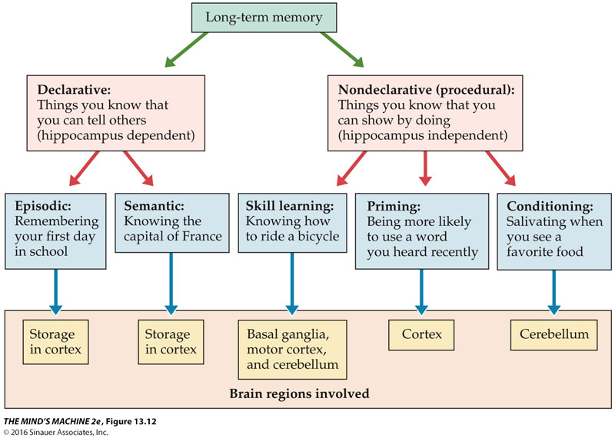
- Full text book “The mind’s machine” is (10) here &
- Full textbook – “Integrating Cognitive Science with Innovative Teaching in STEM Disciplines” is (11) here
Subjects | Examples can be found here –more online – I’ve tried to pick the best
Mathematics | - https://mcsbrent.co.uk/mathagogy-is-this-the-best-we-can-do-part-7-the-spacing-effect/  - https://teachingbattleground.wordpress.com/2015/11/05/teaching-maths-by-oldandrewuk/  Andrew Old - joint most popular teacher blog in the UK  - https://komodomath.com/blog/working-memory-fluency-and-practice-the-science-of-learning-mathematics  - http://teachingmathematics.blog/uncategorized/teaching-changes-predicted-science/  - Why Cognitive Science Matters to Mathematics – Full Textbook here  http://www.cogsci.ucsd.edu/~nunez/web/INTR-04.PDF  - Book: Why Johnny Can't Add Prof Morris Kline  http://www.marco-learningsystems.com/pages/kline/johnny.html
English | - https://mcsbrent.co.uk/english/ - Please see the .ppt of students work on that page  - https://thelearningprofession.wordpress.com/2017/09/10/on-set-text-knowledge-organisers-and-kahoot-quizzes/  - David Didau – joint most popular teacher blog in the UK  http://www.learningspy.co.uk/
Science Practical’s | - https://mcsbrent.co.uk/cheng-reaction-practicals-in-science/  - http://thescienceteacher.co.uk/practical-work/
Physics | - "Education is not the filling of a pail, but the lighting of a fire." – As W. B. Yeats never said  https://gregashman.wordpress.com/  - A thoughtful blog that tries to pull apart the teaching of equations in physics, and how you might assess progress Deep Ghataura- Physics equations and mathematical progression  - Research finds practicing retrieval is best tool for learning  https://phys.org/news/2011-01-tool.html
Chemistry | - Andy Chandler-Grevatt introduces threshold concept mastery tasks for A-level  https://eic.rsc.org/feature/challenging-concepts-in-chemistry/2000069.article  - https://micerportal.wordpress.com/2017/04/06/poster-threshold-concepts-in-ks4-chemistry/  - https://micerportal.files.wordpress.com/2017/04/threshold-concepts-niki-kaiser.jpg  - https://chemdrk.wordpress.com/2017/07/03/threshold-concepts-and-the-space-in-between-part-1/ & https://chemdrk.wordpress.com/2017/07/23/threshold-concepts-and-the-space-in-between-part-2/  - https://eic.rsc.org/feature/making-practical-work-more-effective/3008027.article  - http://www.chemreview.net/CogSciForChemists.pdf
Biology | - http://www.sec-ed.co.uk/best-practice/revision-and-study-skills-retrieval-practice/  - https://www.psychologytoday.com/gb/blog/ulterior-motives/201409/using-cognitive-science-teach-sex-education
Computer Science | - https://mrocallaghanedu.wordpress.com/2016/08/26/knowledge-organisers-new-ocr-gcse-computer-science/
Geography | - https://www.tes.com/teaching-resource/aqa-9-1-gcse-geography-knowledge-organisers-11829773  - http://www.chantryschool.com/wp-content/uploads/2018/03/GCSE-geography-preparation-Matrix2.pdf
History | - https://clioetcetera.com/  - https://pragmaticreform.wordpress.com/2015/03/28/knowledge-organisers/  - https://mcsbrent.co.uk/the-sites-of-memory-history-at-michaela/
Music | - Thoughts on Thinking: Engaging Novice Music Students in Metacognition  https://pdfs.semanticscholar.org/f813/bed9f21610dbdfbca5067118e80e23e634d1.pdf  - A process oriented teaching approach to improvisation in music opens new perspectives for education and enhances creativity  https://www.sciencedaily.com/releases/2017/06/170621103100.htm
Religious Education | - https://mcsbrent.co.uk/to-learn-is-to-follow-were-squeamish-about-scripture/  - https://joeybagstock.wordpress.com/tag/deans-for-impact/
MFL | - Knowledge Organisers are central to the French curriculum at Michaela.  https://jlmfl.wordpress.com/2017/04/23/michaela-french-how-we-use-knowledge-organisers/  - https://educationblog.oup.com/secondary/mfl/tips-for-the-9-1-mfl-gcse-speaking-reading-and-writing-exams-homestraight-part-2

Knowledge organisers - set out the key facts and concepts that students will learn during their studies.
- Art Knowledge Organisers
- Business Knowledge Organisers
- Computing Knowledge Organiser
- Drama Knowledge Organsiser & also see http://www.martinrobinson.net/
- Geography Knowledge Organisers
- History Knowledge Organisers
- Maths Knowledge Organisers
- Media Knowledge Organisers
- PE Knowledge Organisers

Putting it all together
“Some key cognitive principles taken from the Deans for Impact report”
http://thescienceteacher.co.uk/cognitive-science-and-science-teaching/
- Students learn new ideas by relating them to what they already know
  - have clearly established progression maps for key concepts in science education so that you can sequence the curriculum
  - check prior knowledge and build from there
  - start from the concrete and move to the abstract – analogy models will help
- Information is withdrawn in a similar way to how it went well
  - teach for meaning – stories and simple contexts can help here
  - ask students to explain how or why something happened
- Students transfer new information from working memory to long-term memory. Working memory is limited and can be overwhelmed by information that is too challenging
  - don’t challenge too much when first teaching concepts
  - use direct instruction
  - make sure practical work is focused on developing key aspects – be wary of procedural and conceptual demands
- Learning does not happen in an age-related way – it happens in fits and starts
  - have a clear progression map for how concepts should be learnt – learning requires elaboration
  - don’t avoid teaching concepts because they are ‘biologically inappropriate’ e.g. an 8 Yr old can understand atomic structure if they have the necessary prerequisite knowledge
- Deliberate practice is essential for learning new knowledge
  - the act of retrieval on regular low-stakes quizzes that are spaced out overtime can help students remember
  - alternate what topics you are teaching to help memory
- Each subject has a set of facts that aid problem solving and free-up working memory
  - important topics I think to get right: chemical formula, particle model, energy, evolution
- Learning requires motivation
- Feedback is important in acquiring new skills
  - written feedback
  - check for understanding and responsive teaching

Further reading

Johnstone, A.H., 1991. Why is science difficult to learn? Things are seldom what they seem. Journal of computer assisted learning, 7(2), pp.75-83.

Deans for Impact (2015). The Science of Learning. Austin, TX: Deans for Impact.
Please click in the links in blue for further information
- Big ideas of science education
- Challenge
- Deep learning and making meaning
- Diagnostic teaching
- Knowledge versus understanding
- Misconceptions
- Motivation
- Novices and experts
- Progression
- Zooming in and out

